Project Design Phase-II
Data Flow Diagram & User Stories

Date | 02 November 2025
Team ID | NM2025TMID00562
Project Name | Laptop Request Catalog Item
Maximum Marks | 4 Marks

Data Flow Diagram (DFD) Description – Laptop Request Catalog Item

A Data Flow Diagram (DFD) is a graphical representation that illustrates how data moves within the system — showing where information originates, how it flows through processes, and where it’s stored.
In the project “Laptop Request Catalog Item,” the DFD demonstrates how a laptop request is raised, approved, and fulfilled through the ServiceNow Catalog System.
The diagram visualizes the interaction between the Employee (Requester), Manager, IT Admin, and ServiceNow System. When an employee submits a Laptop Request Form via the Service Portal, the request data flows into the Catalog Request Table. The system then triggers an Approval Workflow, which routes the request to the employee’s manager for approval.
Once approved, a Fulfillment Task is automatically created and assigned to the IT Team. The IT Admin updates the CMDB (Configuration Management Database) once the laptop is allocated or delivered. Finally, a Notification is sent to the requester confirming the completion of the process.
This DFD helps clearly understand how data is processed, validated, and updated at each stage — ensuring transparency, automation, and efficiency in laptop allocation workflows
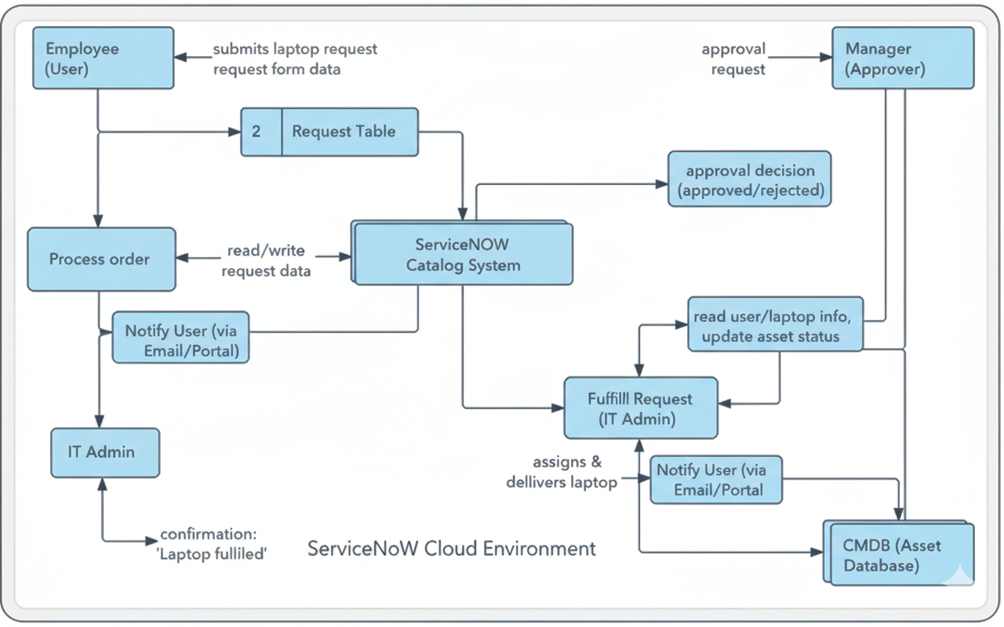

User Stories
User stories define what different users need from the system in simple, goal-focused language.
In this project, they help ensure that employees can raise laptop requests easily, managers can approve them efficiently, and IT teams can fulfill them accurately within ServiceNow.

User Type | Functional Requirement (Epic) | User Story Number | User Story / Task | Acceptance Criteria | Priority | Sprint
Employee | Laptop Request Submission | USN-1 | As an employee, I want to submit a laptop request through the catalog so that I can get a laptop for work. | The system should allow form submission and record the request in the ServiceNow catalog. | High | Sprint-1
Manager | Approval Workflow | USN-2 | As a manager, I want to review and approve or reject the laptop request to ensure only valid requests are processed. | The system should send approval notifications and allow the manager to approve/reject requests. | High | Sprint-1
IT Admin | Fulfillment & Assignment | USN-3 | As an IT admin, I want to assign an available laptop to an approved request and update the CMDB. | The system should automatically update the asset record once a laptop is assigned. | High | Sprint-2
System (Automation) | Notifications | USN-4 | As a system, I should notify the employee when their laptop request is approved, rejected, or fulfilled. | Email and in-app notifications must trigger automatically based on request status. | Medium | Sprint-2
Admin (Reporting) | Request Tracking | USN-5 | As an admin, I want to view reports of laptop requests, approvals, and fulfillment to track the workflow performance. | Dashboard should display summarized request data and status updates. | Medium | Sprint-3

